DCC-GARCH correlation: AUDUSD and USDCHF
Method 09 / GARCH(1,1) + Engle DCC / Alpari D1 full available history

Study setup
Logical pair: AUDUSD , USDCHF
Broker symbols: AUDUSD_i , USDCHF_i
Snapshot: 2026-11-03_majors_alpari_D1
Timeframe: D1
Matched return window: 1999-01-05 to 2026-11-02 (UTC bar dates)
Matched return count n: 7200
Dropped unfinished last bar dated 2026-11-03 UTC after a tick-volume check against the prior complete day.
AUDUSD GARCH(1,1): mu=0.000036, omega=0.005406, alpha=0.052155, beta=0.937245
USDCHF GARCH(1,1): mu=-0.000354, omega=0.003267, alpha=0.042733, beta=0.955789
DCC: a=0.049570, b=0.924292, a+b=0.973863
Burn-in ignored in path summaries and chart: first 60 updates
Complete matched rows (Excel): AUDUSD-USDCHF_DCC_D1.xlsx
Complete matched rows (HTML table): AUDUSD-USDCHF_DCC_D1_data.html

Method carried forward
DCC-GARCH first fits a constant-mean GARCH(1,1) on each matched daily log return of close, ln(close_t / close_t-1), then updates Engle (2002) dynamic conditional correlation on the standardised shocks z = residual / conditional sigma. Quotes are not inverted. Correlation targeting sets Q_bar to the sample correlation of z; a and b are estimated by maximising the bivariate Gaussian DCC likelihood with a >= 0, b >= 0, and a + b < 1. Path summaries ignore the first 60 updates. The headline is rho on the last day. Same-sample Pearson r on log returns is a side check only. A high |rho| does not prove cause, lead-lag, or a trading signal.

Results
Latest DCC rho: -0.121291
Post-burn-in path (n=7140): mean=-0.419801, median=-0.442795, min=-0.764877, max=0.296659, std=0.155770
Share of post-burn-in days with |rho| >= 0.4: 60.00%; |rho| >= 0.7: 0.63%
Same-sample Pearson r: -0.380878
Latest rho minus r: 0.259587

Conclusion
Over 7200 matched daily log-return rows for AUDUSD and USDCHF (broker quote directions unchanged), latest DCC rho is -0.1213 (negative, weak conditional linear link in this sample) with fitted a=0.0496, b=0.9243 (a+b=0.9739). After a 60-day burn-in, path mean is -0.4198 and std is 0.1558. Same-sample Pearson r is -0.3809 (latest rho minus r = 0.2596). This does not establish cause, lead-lag, or a lasting trading rule.

Charts
Daily closes

Daily log returns
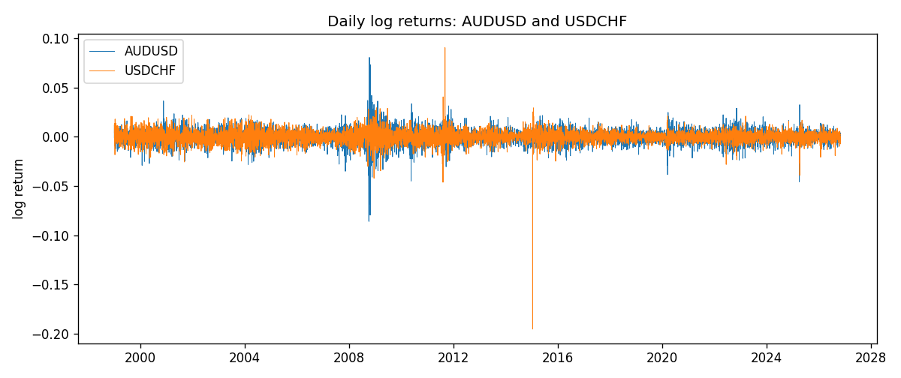
DCC rho path with Pearson r reference
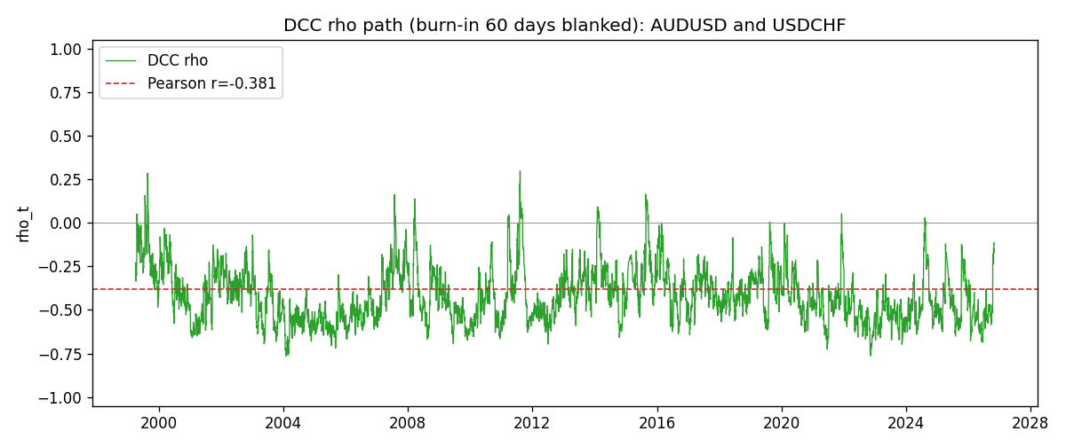

Data report
Every matched row that entered the DCC recursion is stored in the sibling Excel workbook named AUDUSD-USDCHF_DCC_D1.xlsx. Embedding all rows as a Word table is impractical at this length; the Word file holds the column list, column summaries, and the first and last 15 matched rows.
Columns: time, AUDUSD_open, USDCHF_open, AUDUSD_high, USDCHF_high, AUDUSD_low, USDCHF_low, AUDUSD_close, USDCHF_close, AUDUSD_tick_volume, USDCHF_tick_volume, AUDUSD_spread, USDCHF_spread, AUDUSD_real_volume, USDCHF_real_volume, AUDUSD_log_return, USDCHF_log_return, AUDUSD_sigma, USDCHF_sigma, AUDUSD_z, USDCHF_z, q11, q22, q12, rho_t
Column summaries (matched calculation rows)
column | count | mean | std | min | 25% | 50% | 75% | max
AUDUSD_open | 7200 | 0.7519587 | 0.13528421 | 0.4785 | 0.6610975 | 0.731415 | 0.8091275 | 1.10284
USDCHF_open | 7200 | 1.0982244 | 0.25258622 | 0.72022 | 0.920675 | 0.990175 | 1.238625 | 1.8219
AUDUSD_high | 7200 | 0.75601148 | 0.13584385 | 0.4878 | 0.6647 | 0.734785 | 0.8152525 | 1.10795
USDCHF_high | 7200 | 1.1035234 | 0.25433538 | 0.73305 | 0.9249475 | 0.99377 | 1.2436 | 1.8313
AUDUSD_low | 7200 | 0.74790307 | 0.1345988 | 0.4775 | 0.65778 | 0.727495 | 0.804225 | 1.0975
USDCHF_low | 7200 | 1.0930985 | 0.25099871 | 0.08565 | 0.917415 | 0.98668 | 1.232725 | 1.8121
AUDUSD_close | 7200 | 0.75201172 | 0.13526687 | 0.4786 | 0.6612 | 0.731695 | 0.8091975 | 1.10169
USDCHF_close | 7200 | 1.0982149 | 0.25248642 | 0.72025 | 0.92097 | 0.990145 | 1.238625 | 1.8217
AUDUSD_tick_volume | 7200 | 77358.386 | 138142.18 | 109 | 5440 | 43334.5 | 71332.25 | 1234623
USDCHF_tick_volume | 7200 | 74199.562 | 113414.45 | 350 | 12776 | 40195 | 70261.25 | 858589
AUDUSD_spread | 7200 | 30.817222 | 16.887144 | 0 | 13 | 30 | 50 | 50
USDCHF_spread | 7200 | 26.104306 | 24.710129 | 0 | 5 | 16 | 50 | 100
AUDUSD_real_volume | 7200 | 5.2428187e+09 | 1.2538918e+11 | 0 | 0 | 0 | 0 | 3.811512e+12
USDCHF_real_volume | 7200 | 2.3239785e+10 | 8.9047261e+10 | 0 | 0 | 0 | 0 | 1.9331921e+12
AUDUSD_log_return | 7200 | 2.837e-05 | 0.00754598 | -0.08602525 | -0.00385535 | 0.0002835 | 0.00415437 | 0.0806166
USDCHF_log_return | 7200 | -7.168e-05 | 0.00659376 | -0.19545699 | -0.00336083 | 8.057e-05 | 0.00331954 | 0.09051364
AUDUSD_sigma | 7200 | 0.00694155 | 0.00279112 | 0.00391205 | 0.00551453 | 0.00626907 | 0.00758507 | 0.03849455
USDCHF_sigma | 7200 | 0.00655218 | 0.002589 | 0.0035461 | 0.00506174 | 0.00610733 | 0.00733969 | 0.04071881
AUDUSD_z | 7200 | -0.00456916 | 1.0001148 | -8.4753292 | -0.60437795 | 0.03987211 | 0.63649341 | 5.0218131
USDCHF_z | 7200 | 0.04140645 | 0.99903014 | -34.238178 | -0.4819698 | 0.07217528 | 0.59884428 | 6.6801901
q11 | 7200 | 1.0004813 | 0.25429397 | 0.59287509 | 0.84847469 | 0.95271541 | 1.0828992 | 4.4006299
q22 | 7200 | 1.0001112 | 1.7879006 | 0.52918946 | 0.76305688 | 0.86141116 | 0.98811377 | 58.869423
q12 | 7200 | -0.39552891 | 0.187354 | -2.7856353 | -0.50429505 | -0.386079 | -0.28416787 | 0.52883533
rho_t | 7200 | -0.4170572 | 0.15816485 | -0.76487739 | -0.53600661 | -0.44128925 | -0.32337245 | 0.29665897
First 15 matched rows (selected columns)
time | AUDUSD_log_return | USDCHF_log_return | AUDUSD_sigma | USDCHF_sigma | AUDUSD_z | USDCHF_z | q11 | q22 | q12 | rho_t
1999-01-05 | -0.00080418179 | 0.0039424743 | 0.0062870538 | 0.0083887777 | -0.13361965 | 0.512148 | 1 | 1 | -0.39496174 | -0.39496174
1999-01-06 | 0.011836351 | 0.013605652 | 0.0061338327 | 0.0082689729 | 1.9238312 | 1.688175 | 0.95131474 | 0.96343177 | -0.37877561 | -0.3956484
1999-01-07 | 0.0088650256 | -0.0093883841 | 0.0065624715 | 0.008602733 | 1.3453976 | -1.0501968 | 1.0888962 | 1.0579021 | -0.19943003 | -0.18581235
1999-01-08 | 0.00031515916 | 0.011040268 | 0.0067059433 | 0.008634227 | 0.041644699 | 1.3196421 | 1.1223227 | 1.0586199 | -0.26469437 | -0.24283753
1999-01-11 | 0.0072213815 | 0.0052963193 | 0.0065339301 | 0.0087822874 | 1.0997193 | 0.6433564 | 1.0635776 | 1.0909361 | -0.25225404 | -0.2341822
1999-01-12 | -0.0048608485 | -0.0098275602 | 0.0065762069 | 0.0086838705 | -0.74461475 | -1.0909581 | 1.0691435 | 1.0549988 | -0.20840817 | -0.19623243
1999-01-13 | -0.0078902098 | -0.018259701 | 0.0065056678 | 0.0087314267 | -1.2183379 | -2.0507392 | 1.0418228 | 1.0602627 | -0.16268522 | -0.15479054
1999-01-14 | -0.002696916 | -0.0024256692 | 0.0065943011 | 0.0093217605 | -0.41441969 | -0.22225927 | 1.0626658 | 1.2145995 | -0.036840876 | -0.032427618
1999-01-15 | 0.007123101 | 0.01794228 | 0.0064564694 | 0.0091413168 | 1.0976911 | 2.0014733 | 1.0168646 | 1.1512311 | -0.039809126 | -0.036793392
1999-01-18 | 0.00094592471 | -0.0031856384 | 0.0064984797 | 0.0097211566 | 0.14003776 | -0.29130452 | 1.025746 | 1.2887849 | 0.061787409 | 0.053739033
1999-01-19 | 0.0072225153 | -7.2518946e-05 | 0.0063374951 | 0.0095389905 | 1.1339848 | 0.029489762 | 0.97519865 | 1.2215578 | 0.044764242 | 0.04101358
1999-01-20 | 0.0012507819 | 0.0072259871 | 0.0063935606 | 0.0093434257 | 0.19001771 | 0.81124513 | 0.99124952 | 1.155257 | 0.032709689 | 0.030566493
1999-01-21 | 0.00078094498 | -0.0038232689 | 0.0062393823 | 0.0092855765 | 0.11941131 | -0.37363834 | 0.94413152 | 1.1265557 | 0.027551388 | 0.026714737
1999-01-22 | -0.012252745 | -0.0001445609 | 0.0060873942 | 0.0091242042 | -2.0187024 | 0.02293467 | 0.89949771 | 1.0743245 | 0.012930641 | 0.013153832
1999-01-25 | -0.0039591468 | 0.0024546976 | 0.0065686715 | 0.0089386297 | -0.60819589 | 0.31420019 | 1.0595431 | 1.0191533 | -0.0006665634 | -0.00064144938
Last 15 matched rows (selected columns)
time | AUDUSD_log_return | USDCHF_log_return | AUDUSD_sigma | USDCHF_sigma | AUDUSD_z | USDCHF_z | q11 | q22 | q12 | rho_t
2026-10-13 | 0.0035007712 | -0.0024955621 | 0.0045189157 | 0.0047400419 | 0.76675009 | -0.45184001 | 0.78016833 | 0.70224111 | -0.37633836 | -0.50844174
2026-10-14 | -0.0015193215 | 0.0029388325 | 0.0045061971 | 0.0046901396 | -0.34512774 | 0.70203751 | 0.77638363 | 0.68533367 | -0.37534346 | -0.51456429
2026-10-15 | -0.0075447063 | -0.0097855323 | 0.0044382693 | 0.0046706428 | -1.7080078 | -2.0193603 | 0.74964726 | 0.68401706 | -0.36926086 | -0.51566937
2026-10-16 | 0.0033906408 | -0.0036230826 | 0.0046903899 | 0.0049978611 | 0.71523875 | -0.65413205 | 0.86364154 | 0.86050764 | -0.18065615 | -0.20956012
2026-10-19 | 0.0050859986 | 0.0036351779 | 0.0046633358 | 0.004965657 | 1.0829386 | 0.80331757 | 0.84975312 | 0.84270855 | -0.20049434 | -0.23692835
2026-10-20 | 0.0034620426 | -0.0026281224 | 0.0047172762 | 0.0049572482 | 0.72629846 | -0.45878294 | 0.86969152 | 0.83703507 | -0.15251526 | -0.17875527
2026-10-21 | 0.0036066384 | -0.00040027413 | 0.0046913769 | 0.0049026132 | 0.76112969 | -0.0094750746 | 0.85613536 | 0.8102361 | -0.16780942 | -0.20148342
2026-10-22 | -0.0012672558 | -0.0048036381 | 0.0046726221 | 0.0048269862 | -0.27889009 | -0.92186231 | 0.8461737 | 0.77503682 | -0.16578569 | -0.20471804
2026-10-23 | 0.0023765656 | 0.005652514 | 0.0045926439 | 0.004841753 | 0.50965707 | 1.2405291 | 0.81210478 | 0.78462428 | -0.15081325 | -0.18893073
2026-10-26 | -0.0032032829 | 0.0018407959 | 0.0045381755 | 0.0049269191 | -0.71376152 | 0.44543403 | 0.78963548 | 0.82764391 | -0.11837823 | -0.14643226
2026-10-27 | 0.0016669876 | 0.0026100526 | 0.0045155716 | 0.0048717424 | 0.36121573 | 0.6083807 | 0.78124524 | 0.8009576 | -0.1354994 | -0.17129273
2026-10-28 | 0.0040915541 | -0.0010142111 | 0.0044486078 | 0.0048359792 | 0.91166993 | -0.13655758 | 0.75470411 | 0.78480363 | -0.1246709 | -0.161993
2026-10-29 | -0.0040915541 | -0.0048680164 | 0.0044661635 | 0.0047642531 | -0.92415924 | -0.94751366 | 0.76490454 | 0.75244972 | -0.13172688 | -0.17363291
2026-10-30 | 0.0010102376 | 0.00071594559 | 0.0044859712 | 0.0047845738 | 0.21719833 | 0.22358671 | 0.77546928 | 0.76612419 | -0.088670981 | -0.1150402
2026-11-02 | -0.0049184984 | -0.0071459744 | 0.0044103446 | 0.0047175937 | -1.1233568 | -1.4397494 | 0.74523614 | 0.73673814 | -0.089873884 | -0.12129139

